**Name: Hamza Mehmood Mughal**

**Intern ID: TN/IN02/PY/009**

**Task no:** **13**

**Question: Write calc(a,b,op).**

**Write factorial(n) recursive.**

**Write calc(a,b,op):**

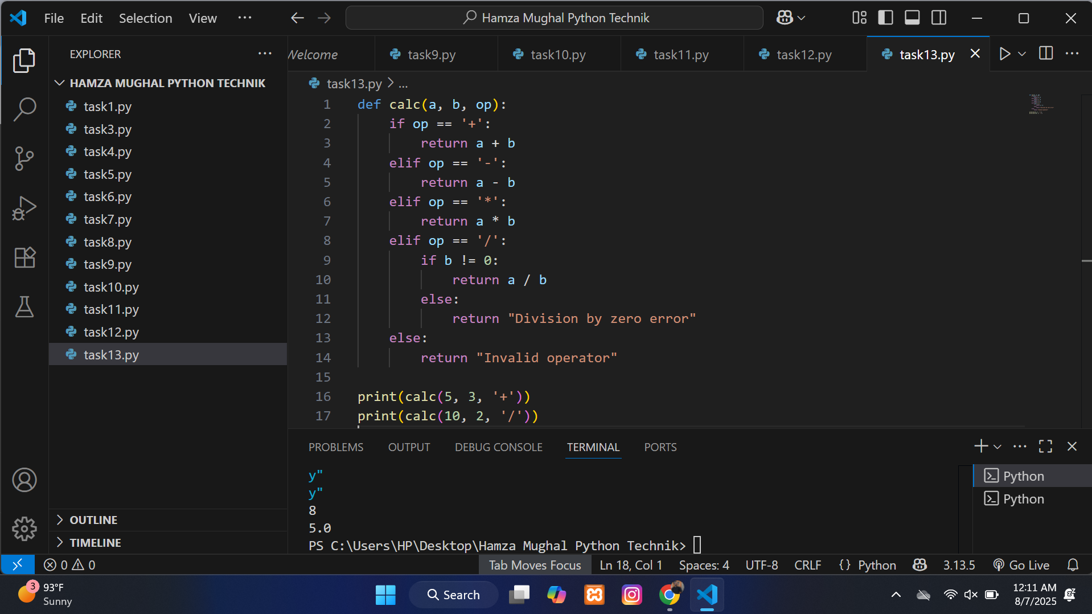

**Write factorial(n) recursive:**

